Chemistry Guided Review/Questions Standard 1.3
(Periodic Table)

Periodic Table
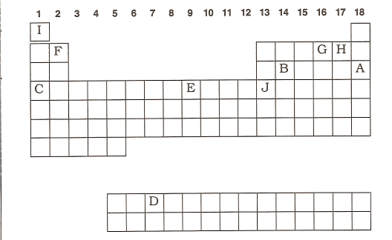

The letters inside the table have no significance here. They are from another worksheet.
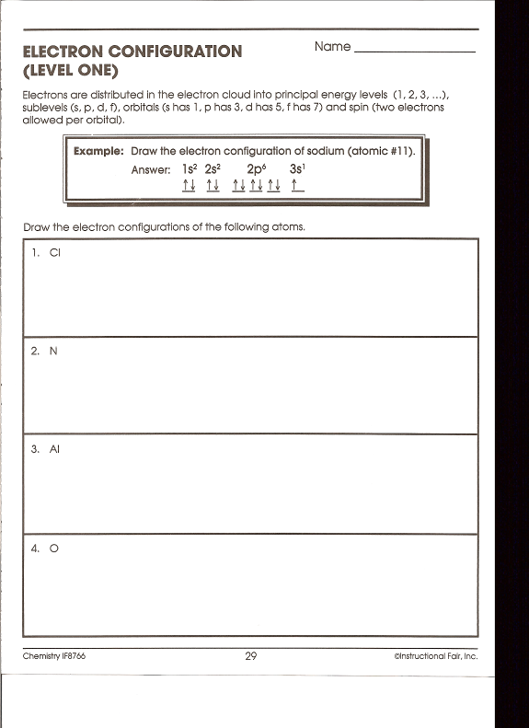
- Horizontal rows are called ______________
- Columns are called ___________ or ____________
- Name group 1___________, 2 ________________, 3-12______________, 17__________________, 18________________.
- Elements are arranged according to their __________________
- Elements within a group have the same number of ____________________
- Name the groups with the following ionic charges: +1____, +2____, +3____, -3____, -2____, -1____.
- Label Zn and Ag with their charges.
- As you go across the periodic table, the elements go from ( metals / nonmetals ) to ( metal / nonmetals ).
- Draw in the metalloid line. Mark the six metalloids.
- Where are the s, p, d and f sublevels?
- Where are the most active metals?
- Where are the most active nonmentals.
- As you go across a period, the atomic size ( decreases / increases ).
- As you go down a group, the atomic size ( decreases / increases ).
- A negative ion is called a ___________ and is ( larger / smaller ) that its atom.
- A positive ion is called a ___________ and is ( larger / smaller ) that its atom.
- As you go down a group, the ionization energy generally (decreases / increases ).
- Where is the highest electronegativity found? Which element. Why?
- Where is the lowest electronegativity found?
- A colored ion generally indicates a __________________.
Electron Configuration
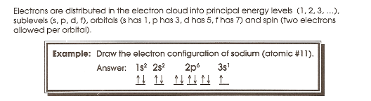

Draw the orbital notation, electron configuration and noble gas configuration for the following. Don’t forget HUND’S RULE, HUND’S RULE, HUND’S RULE!!!

- Cl

- O

Lewis dot diagrams
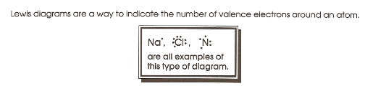

- Calcium 5. Bromine

- Potassium 6. Carbon

- Argon 7. oxygen

Aluminum 8. helium

