Chemistry NCFE Guided Review 1.2
(Bonding)

Chm.1.2.1 Compare (qualitatively) the relative strengths of ionic, covalent, and metallic bonds.
Chm.1.2.2 Infer the type of bond and chemical formula formed between atoms.
Ions
Cation:
Anion:
Stability =
Bond Types
Bond | Ionic | Covalent | Metallic
Formed Between
Electrons
ΔEN
Relative Strength

Charges and Valence Electrons
 | Group 1 | Group 2 | Group 13 | Group 14 | Group 15 | Group 16 | Group 17 | Group 18
Valence Electrons
Oxidation/Charge

Diatomic Elements
*KNOW THE 7 DIATOMIC ELEMENTS!!! (They are NOT listed anywhere on the reference table…and not knowing them will mess you up in many ways!)

Lewis Diagrams for Covalent Bonds

Chm.1.2.3 Compare inter- and intra- particle forces.
Types of Intermolecular Forces
- London Dispersion (aka van der Waals) =

- Dipole-dipole =

- Hydrogen Bond =
Why are intermolecular forces weaker than bond types?
Intraparticle Forces
- In general, the ________ the bond length, the _________ bond energy. The __________ the number of bonds, the ________ the bond length.
Chm.1.2.4 Interpret the name and formula of compounds using IUPAC convention.
Binary Compounds of 2 Nonmetals (____________)
- Names involve ______________. Formulas use the prefixes to determine ________________.
1 = 5= Example: dinitrogen pentasulfide =
2= 6= CCl₄ =
3= 7=
4= 8=

Binary Compounds of Metal/Nonmetal
- Use ___________ ________ to write ___________ for formulas (Cross them and reduce if possible!)
- Names will follow this convention:
Cation Name =
Anion Name =
- Remember: the charge of transition metals are given as ________ _________ in the names, or are the __________ subscript in the ___________ (be careful when “un-crossing” due to reduction)
Examples:
Magnesium chloride = Tin (IV) oxide =
Beryllium oxide = Lithium nitride =
CuCl₂ = FeS =
Ternary Compounds (__________________)
- Polyatomic ions are listed on the reference table. DO NOT CHANGE THEIR SUBSCRIPTS….EVER! If it’s a subscript on the table, it has to be a subscript in the formula!
- Otherwise, cross charges like in binary compounds to get formulas.
- Names of compounds containing polyatomic ions will use the polyatomic names for the cation/anion.
Examples:
Lithium sulfate = Sodium nitrate =
Ammonium phosphite = Iron (III) acetate =
Li₂CO₃ = Ag₂SO₄ =
Acids
- If binary, use the naming convention: hydro(stem)ic acid
- If ternary, use the naming convention: (stem)ic acid (for polyatomics ending in –ate)
- If ternary, use the naming convention: (stem)ous acid (for polyatomics ending in –ite)

Examples:
HCl = Acetic Acid =
HNO₃ = Sulfuric Acid =

Chm.1.2.5 Compare the properties of ionic, covalent, metallic, and network compounds.
Bond Properties
 | Ionic | Covalent | Metallic
Melting/Boiling Points
Conductivity
Physical Properties

Valence Shell Electron Pair Repulsion Theory (VSEPR)
- Determines ____________ of covalent molecules
- Electrons will repel each other to make the greatest distance between them (changes bond angles/shapes)
- Know the shapes:
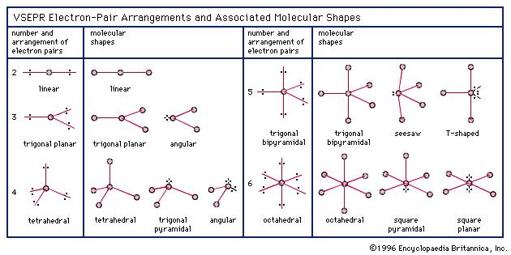

Polarity
Polar = Nonpolar =

Sample Questions

1. Which statement compares the amount of energy needed to break the bonds in CaCl2 (E1) and C12H22O11 (E2)?
- E1 > E2, as CaCl2 is a covalent compound.
- E1 < E2, as CaCl2 is a covalent compound.
- E1 > E2, as CaCl2 is an ionic compound.
- E1 < E2, as CaCl2 is an ionic compound.

2. Which statement describes the compound formed between sodium and oxygen?
- It is NaO2, which is ionic.
- It is NaO2, which is covalent.
- It is Na2O, which is ionic.
- It is Na2O, which is covalent.

3. At STP, fluorine is a gas and iodine is a solid. Why?
- Fluorine has lower average kinetic energy than iodine.
- Fluorine has higher average kinetic energy than iodine.
- Fluorine has weaker intermolecular forces of
- attraction than iodine.
- Fluorine has stronger intermolecular forces of attraction than iodine.

4. What is the IUPAC name for the compound represented by the formula Mg(OH)2?
- Magnesium hydroxide.
- Magnesium dihydroxide.
- Magnesium (II) hydroxide.
- Magnesium (II) dihydroxide.

5. An unknown substance is tested in the laboratory. The physical test results are listed below.
• Nonconductor of electricity • Insoluble in water
• Soluble in oil
• Low melting point
Based on these results, what is the unknown substance?
- ionic and polar.
- ionic and nonpolar.
- covalent and polar.
- covalent and nonpolar.

6. What is the name of the compound PbO2 ?
- A lead oxide
- B lead(II) oxide
- C lead oxide(II)
- D lead(IV) oxide

