Physical Science NCFE Guided Review 3.3
(Electricity and Magnetism)

3.3.1 Summarize static and current electricity.
- Opposite charges ___________, like charges _____________
- 3 methods of charging:
  - Induction – objects get charged from being _______ a charged object (___________ _______)
  - Conduction – objects get charged by ________ a charged object (_________ __________)
  - Friction – objects get charged by _________ a charged object (__________ ___________)
3.3.2 Explain simple series and parallel DC circuits in terms of Ohm’s law.
Ohm’s Law Equation:

Know these:
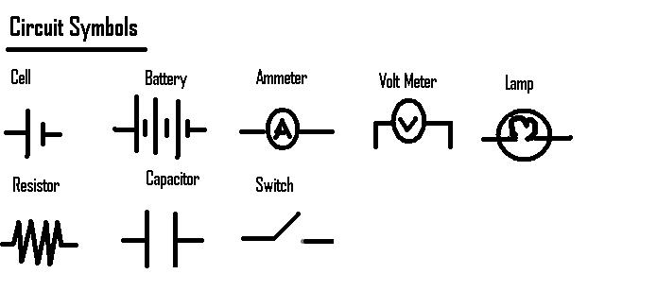
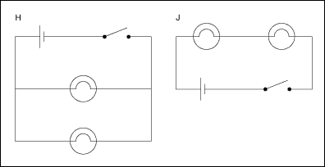

3.3.3 Explain how current is affected by changes in composition, length, temperature, and diameter of wire.
- If the _____________ of the wire ___________, the ___________ will ________ (Inverse relationship)
- Increasing length = ___________ resistance, current will ___________
- Increasing temperature = ___________ resistance, current will ___________
- Increasing diameter = ___________ resistance, current will _____________

3.3.4 Explain magnetism in terms of domains, interactions of poles, and magnetic fields.
- Like poles ___________, opposite ______________
  - North will __________ North
  - North will ___________ South
- Magnetic Field around a wire/wire coil:

- Strength of an electromagnet will increase with:

3.3.5 Explain the practical application of magnetism.
- Generators – change ________ energy to ___________ energy (uses electromagnetic induction)
- Motors – change _________ energy to __________ energy
- Other practical applications:

Sample Questions
1. A student noticed that a woolen sweater was clinging to a silk scarf. Why would these pieces of clothing be clinging together?
- The static charge of both pieces of clothing is the same.
- The static charge of both pieces is positive.
- The static charge of both pieces is negative.
- The static charge of one piece of clothing is positive and the other is negative.

2. The leaves of a neutral electroscope move apart when a negatively charged object is brought near. Which statement explains why this occurs?
  - Electrons moved downward to the leaves of the electroscope.
  - Electrons moved to the top of the electroscope.
  - Protons moved toward the top of the electroscope.
  - Protons moved downward to the leaves of the electroscope.

3. What is the current in a circuit that has a potential difference of 120 volts and a resistance of 2 ohms?
  - 240 amps
  - 60 amps
  - 40 amps
  - 0 amps

4. A section of copper wire has a set resistance. Which of the following changes would provide less resistance?
  - a longer copper wire of the same thickness
  - a thinner copper wire of the same length
  - a thicker copper wire of the same length
  - increase in temperature of the wire

