Physical Science NCFE Guided Review 3.2
(Waves)

3.2.1 Explain the relationships among wave frequency, wave period, wave velocity, amplitude, and wavelength through calculation and investigation.
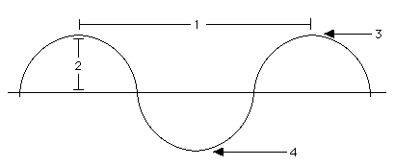

- Period = Frequency =
- Relationship between Period and Frequency:
- Wave Equation:

- As _____________ increases, ________________ increases. (Direct relationship)

3.2.2 Compare waves (mechanical, electromagnetic, and surface) using their characteristics.
 | Mechanical | Electromagnetic | Surface
How are they produced?
Relative Speed?
Medium Required
Motion of Particles

3.2.3 Classify waves as transverse or compressional (longitudinal).
- Tranverse = particles move _______________ to the energy source
- Longitudinal/Compressional = particles move ____________ to the energy source
3.2.4 Illustrate the wave interactions of reflection, refraction, diffraction, and interference.
- Reflection =

- Refraction =

- Diffraction =

- Constructive Interference =
  - Sound gets _____________________, Light gets _______________

- Destructive Interference =
  - Sound gets _____________________, Light gets _______________

Sample Questions
1. What is the effect on frequency of a wave when the wavelength is doubled?
- Frequency is also doubled.
- Frequency remains the same.
- Frequency is reduced to one-fourth.
- Frequency is reduced to one-half.
2. A sound wave with a frequency of 240 hertz travels through a material at a speed of 340 meters per second. Which statement is true about a sound wave with a frequency of 300 hertz traveling in the same material?
- It would travel at the same speed.
- It would have the same wavelength.
- It would have the same period.
- It would have the same frequency.
3. Which statement is true for all types of waves?
- Wave speed is determined by the frequency.
- Wave speed increases as the wavelength of the wave increases.
- Wave motion transports particles of matter.
- Wave motion transfers energy from one place to another.
4. Which type of wave can travel in a vacuum?
- sound
- mechanical
- surface
- electromagnetic
5. Which type of wave would be classified as compressional?
- visible light
- ultrasound
- x-rays
- radio waves
6. Which wave interaction best explains glare on the windshield of a car?
- diffraction
- interference
- reflection
- refraction

7. What wave interaction best explains the production of an image on a glass window as you walk by a store front?
- diffraction
- interference
- reflection
- refraction
8. The bending and change in speed of water waves as they approach a shoreline is explained by what process?
- diffraction
- interference
- reflection
- refraction

