Physical Science NCFE Guided Review: 2.1
(Classification of Matter, Phases, Bohr Models)

PSc.2.1.1 Classify matter as homogeneous or heterogeneous; pure substance or mixture; element or compound; metals, nonmetals, or metalloids; solution, colloid, or suspension.
Classification | Category | Sub-Category | Definition | Examples
Pure Substance | Element | Metal
 |  | Nonmetal
 |  | Metalloid
 | Compound | Ionic
 |  | Covalent
 |  | Metallic
Mixture | Heterogeneous | Suspension
 |  | Colloid
 | Homogeneous | Solution

PSc.2.1.2 Explain the phases of matter and the physical changes that matter undergoes.
Phases
Solid: Liquid: Gas:

Melting: from ________ to _________, energy is _________ (______________)
Freezing: from _________ to ________, energy is __________ (_______________)
Vaporization: from _______ to ________, energy is _________ (_______________)
Condensation: from _______ to ________, energy is __________ (_______________)
 | Boiling | Evaporation
Particles Involved
Energy Requirement
Solubility

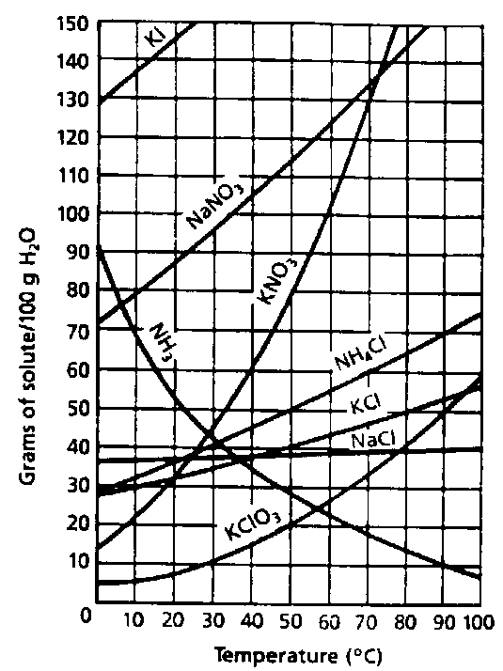

1. How many grams of potassium nitrate can dissolve in 200 grams of water at 40 degrees Celsius?

2. If 100 grams of sodium nitrate are dissolved in 100 grams of water at 50 degrees Celsius, what type of solution will result?

Saturated:
Unsaturated:
Supersaturated:
Parts of Solution
Solute:
Solvent:
“Like dissolves like”

PSc.2.1.3 Compare physical and chemical properties of various types of matter.
Physical Property | Chemical Property
Physical Change | Chemical Change

Density
Equation:

Concept:

Chemical and Physical Properties of Various Substances
Substance | Physical Properties | Chemical Properties
Metals
Nonmetals
Metalloids
Sugar
Baking Soda
Salt
Cornstarch
Rubbing Alcohol
Water

PSc.2.1.4 Interpret the data presented in the Bohr model diagrams and dot diagrams for atoms and ions of elements 1 through 18.
Subatomic Particles
 | Location | Charge | Mass | Determined By:
Protons
Neutrons
Electrons

Element | Mass Number | Atomic Number | Protons | Neutrons | Electrons
¹⁸C
Lithium—20
U—238
Chlorine

Isotopes

Definition =

Symbols: -or-

Bohr Model Lewis Dot Diagram

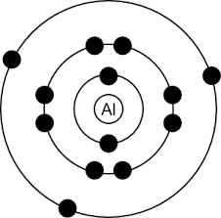

Sample Questions

1. Which material would be classified as homogeneous?
- stainless steel bolt
- granite rock
- soda pop
- apple
2. Which of the elements listed is a metalloid?
- carbon
- antimony
- sulfur
- helium
3. What classification would best describe a material with the following characteristics?
-white liquid
-not separated by filtration -scatters light
- element
- solution
- colloid
- suspension
5. The graph below shows a heating curve for a pure substance at normal atmospheric pressure. Use the graph to answer the questions that follow.
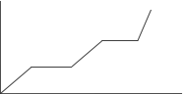
What happens to the molecules during segment II?
  - Energy of the molecules forms chemical bonds.
  - Energy of the molecules breaks chemical bonds.
  - Energy of the molecules overcomes intermolecular attractions.
  - Energy of the molecules strengthens intermolecular attractions.
6. What phase change occurs during segment IV of the graph?
  - solid to liquid
  - solid to gas
  - liquid to gas
  - liquid to solid
7. What process occurs during segment III?
  - increase in temperature of the solid
  - increase in temperature of the liquid
  - melting of the solid
  - boiling of the liquid
8. Which is a characteristic property of aluminum?
  - reacts with oxygen to form rust
  - reacts with water
  - dissolves in alcohol
  - forms into a wire
9. Which element is represented by the diagram below?
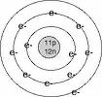
  - magnesium
  - sodium
  - titanium
  - vanadium
10. Which element could have the dot diagram shown below?
:X
  - Carbon
  - Magnesium
  - Helium
  - Potassium

