Chemistry NCFE Guided Review 2.2
(Reactions and Stoichiometry)

Chm.2.2.1 Explain the energy content of a chemical reaction.
Collision Theory
- Molecules must collide in order to react
- They must collide in correct and appropriate orientation
- They must collide with enough energy to equal or exceed the activation energy
Energy Diagrams
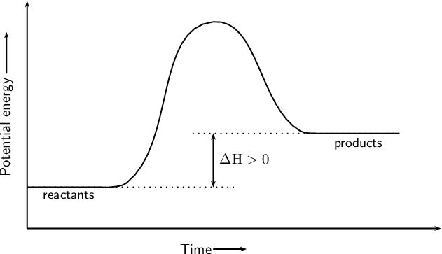
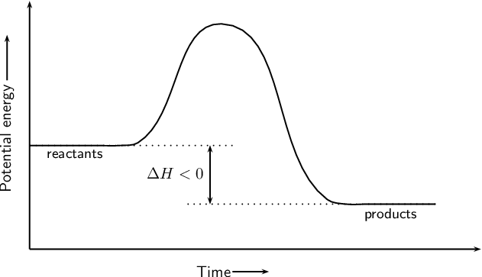
Chm.2.2.2 Analyze the evidence of chemical change.
Determining if a Reaction Occurred
- _______________ Formation – a precipitate is a _____________ that forms when liquids react. Check your solubility rules!! Precipitates are ____________________.
- _____________ Testing – Know the following:
  - Oxygen =
  - Carbon Dioxide =
  - Hydrogen Gas =
- ___________ Change
- ___________ Change
  - Exothermic = negative
  - Endothermic = positive
Chm.2.2.3 Analyze the law of conservation of matter and how it applies to various types of chemical equations (synthesis, decomposition, single replacement, double replacement, and combustion).
- Use the reference table to predict products
  - Example: What are the products for a reaction between lithium oxide and water?
  - Example: What are the products for the decomposition of potassium chlorate?
- Make sure to check the ___________ __________ for single replacement! Elements above other elements will replace the lower ones (not the other way around!)
- Remember that ________________ reactions are just ___________ ____________ reactions!
- Net Ionic Equations: stem from ___________ ____________ reactions
  - Show only the ions that create the _________________
  - Other ions are called ______________ _____________
  - Example: Write the net ionic equation for the reaction between lead II nitrate and sodium fluoride.
- Remember that double displacement reactions in which all reactants/products are aqueous result in ______ ______________!
- Be able to balance!!!!
  - Examples: ______NaCl + ____MgF₂ ____MgCl₂ + _____NaF
____ CoBr₃ + ____ CaSO₄ ____ CaBr₂ + ____ Co₂(SO₄)₃
___ C₂H₄O₂ + ___ O₂ ___ CO₂ + ___ H₂O

Chm.2.2.4 Analyze the stoichiometric relationships inherent in a chemical reaction.
- Recognize that coefficients represent __________!
  - Example: Write the mole ratio for cobalt III bromide and calcium bromide from the example above.
- Be able to convert mol-mol, particle-particle, volume-volume, or mass-mass…yes, the stoichiometry!
  - Examples:
1. How many moles of oxygen are made if 12.0 moles of potassium chlorate react?
2 KClO₃ 2 KCl + 3 O₂

2. How many grams of potassium chloride are produced from 2.5 g of potassium and excess chlorine?
2 K + Cl₂ 2 KCl

3. What volume of chlorine gas is needed to react with excess potassium to produce 56.7 L of potassium chloride?
2 K + Cl₂ 2 KCl

4. How many molecules of oxygen gas are produced from using 8.7 x 10²⁴ particles of potassium chlorate?
2 KClO₃ 2 KCl + 3 O₂

Chm.2.2.5 Analyze quantitatively the composition of a substance (empirical formula, molecular formula, percent composition, and hydrates).
- Calculate Empirical Formula

Example: A compound consists of 72.2% magnesium and 27.8% nitrogen by mass. What is the empirical formula?

- Calculate Molecular Formulas
  - Find the empirical formula first
  - Calculate the molar mass of the empirical formula
  - Divide the molecular mass (given) by the empirical formula mass
  - Multiply empirical subscripts
  - MOLECULAR FORMULAS ARE MULTIPLES OF EMPIRICAL FORMULAS!

Example: Caffeine has the following percent composition: carbon 49.48%, hydrogen 5.19%, oxygen 16.48% and nitrogen 28.85%. Its molecular weight is 194.19 g/mol. What is its molecular formula?

- Calculate percent composition by mass:
  - Find molar mass (from periodic table)
  - Divide individual parts by the whole molar mass
  - Multiply by 100 to make it a percentage

Example: Calculate the percent by mass of glucose, C₆H₁₂O₆ .

- Determine the composition of hydrates
  - Hydrates = compounds linked to ________________
  - Anhydrous = _____________ _______________
  - To name: use the normal name of the compound + hydrate (with prefix to indicate number)

Example: A hydrate of Na₂CO₃ has a mass of 4.31 g before heating. After heating, the mass of the anhydrous compound is found to be 3.22 g. Determine the formula of the hydrate and then write out the name of the hydrate.

