Biology Essential Standard 1.1
Understand the relationship between the structures and functions of cells and their organelles.

Bio.1.1.1 Summarize the structure and function of organelles in eukaryotic cells:
Match these organelles with their functions:
  - Nucleus 1. Sites of photosynthesis, contain chlorophyll.
  - Plasma Membrane 2. Powerhouse of the cell, where cell respiration occurs.
  - Cell Wall 3. Brain of the cell, contains the DNA & chromosomes.
  - Mitochondria 4. Sites of protein synthesis, where mRNA & tRNA meet.
  - Vacuoles 5. Cell’s outer boundary, lipids & proteins, semipermeable.
  - Chloroplasts 6. Found in plants only to maintain structure, not semipermeable.
  - Ribosomes 7. Large in plants, small in animals, used for storage.

- Describe how these organelles interact with each other to perform the function of the cell:
  - Nucleus and ribosome -
  - Plasma membrane and mitochondria –
  - Cell wall and vacuole
  - Cell wall and chloroplasts -
- Draw a plant and animal cell and label the above organelles:

- Explain how the structure of each organelle determines it function. (Example: folded inner membrane in mitochondria increases surface area for energy production during aerobic cellular respiration).
- Summarize how these organelles interact to carry out life functions.(Example: DNA codes for proteins which are assembled by the ribosomes and used as enzymes for energy production at the mitochondria).
Match these:
  - energy production and use 1. Wastes stored in vacuole are sent to plasma membrane.
  - transport of molecules 2. Plasma membrane allows entrance, cytoplasm circulates.
  - disposal of waste 3. Mitochondria makes ATP, ribosome uses it in protein synthesis.
  - synthesis of new molecules 4. Nucleus sends mRNA to ribosome, tRNA brings AA to put
protein together.

- How do you determine total power magnification of a light microscope? (choose one)
  - Objective x Objective b. Ocular x Objective c. Ocular + Objective
- Which reveal greater detail about eukaryotic and prokaryotic cell differences? (choose one)
Scanning/electron transmission microscopes or light microscopes
Bio 1.1.2 Compare prokaryotic and eukaryotic cells in terms of their general structures (plasma membrane and genetic material) and degree of complexity.
  - Which are more complex, prokaryotic cells or eukaryotic cells? (circle)
  - Compare the structure of prokaryotic and eukaryotic cells. Which of these organelles are found in each type of cell? (check which are found in each)
 | Mitochondria | Nucleus | Vacuole | Chloroplasts | Ribosomes
Prokaryote
Eukartyote

 | DNA | RNA | Genetic material enclosed in nuclear membrane | Plasmids | Smaller cells | Larger cells
Prokaryote
Eukartyote

  - What are plasmids?

Bio 1.1.3 Explain how instructions in DNA lead to cell differentiation and result in cells specialized to perform specific functions in multicellular organisms.
- Compare a variety of specialized cells and understand how the functions of these cells vary:
Match these cells with their functions:
  - nerve cells 1. Vascular tissue in plants that carry water.
  - muscle cells 2. Vascular cells that carry oxygen & nutrients & fight disease.
  - blood cells 3. Cells which send impulses back and forth to brain and spinal cord.
  - sperm cells 4. The male gamete.
  - xylem 5. Vascular tissue in plants that carry food.
  - phloem 6. Cells which flex & extend (contract) to allow movement.
- Multicellular organisms begin as _____________________________masses of cells and variation in ____________ expression and ____________activity determines the differentiation of cells and ultimately their specialization. (word bank - DNA, gene, undifferentiated)
- During the process of differentiation, are all parts of the DNA activated?
  - Which parts of the DNA are activated and what do they determine?
- Do all cells in an organism contain the same DNA?
- Do all cells initially have the potential to become any type of cell?
- What is the process in which the cell becomes specialized for its particular job? (choose one)
  - Crossing over b. differentiation c. natural selection
- Can cell differentiation be reversed?
- Do all of the cells of a multicellular organism have exactly the same chromosomes?
  - Know this: Different parts of the genetic instructions are used in different types of cells, influenced by the cell's environment and past history.
- Can chemical signals be released by one cell to influence the development and activity of another cell?
  - Give an example.
- What is the name for cells which have not yet differentiated into various cell types? (choose one)
  - Blood cells b. bone marrow cells c. stem cells
- List 3 types of Adult Stem Cells.
- How are Embryonic stem cells different from Adult Stem Cells?

Biology Essential Standard 1.2
Analyze the cell as a living system.

Bio.1.2.1 Explain how homeostasis is maintained in a cell and within an organism in various environments (including temperature and pH).
- What is a solution used to stabilize the pH of a liquid? (choose one)
  - Acid b. enzyme c. base d. buffer
- Which or your cells respond to maintain temperature and how do they do this?
- Which of your cells respond to maintain glucose levels and how do they do this?
- Which of your cells respond to maintain water balance and how do they do this?
- Compare the mechanisms of active vs. passive transport: (check which apply)

 | Diffusion | Low to High Concentration | High to Low Concentration | ATP | Osmosis | With the Concentration Gradient | Against the Concentration Gradient
Active Transport
Passive Transport

- The movement of particles from an area of high concentration to an area of low concentration without energy being used from the cell: (choose the best choice) diffusion active transport osmosis
- The movement of water from an area of high concentration to an area of low concentration across the cell membrane without energy being used from the cell
- Explain changes in osmotic pressure that occurs when cells are placed in solutions of differing concentrations. Can you describe what happens to cells in those different solutions:
 | Isotonic | Hypotonic | Hypertonic
Cells placed in this type of solution do not change size.
Cells placed in this type of solution shrink.
Cells placed in this type of solution do not change size.
High osmotic pressure inside the cell.
Low osmotic pressure inside the cell.
Little to no osmotic pressure builds up inside the cell.
A red blood cell placed in salt water.
A red blood cell placed in distilled water.
A red blood cell placed in solution that simulates the blood stream.

Bio.1.2.2 Analyze how cells grow and reproduce in terms of interphase, mitosis and cytokinesis.
- Place these 5 steps of the cell cycle in order: (they are NOT in order):
  - Cytokinesis, Growth1 (G1), Mitosis, Growth2 (G2), Synthesis (S)

- Which type of reproduction uses mitosis to form the cells?

- Label the PHASES and the parts of these cells in the process of mitosis and describe what is occurring in each phase.

Phase: _________ _________ _________ _________
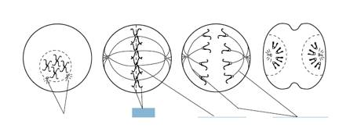

Bio.1.2.3 Explain how specific cell adaptations help cells survive in particular environments (focus on unicellular organisms).
- Explain how various structures of unicellular organisms help that organism survive and list an organism that has these structures: (match each with their definition/examples):
 | Long whip-like tails that are used in locomotion | Extensions of the cytoplasm that are used in locomotion & nutrition. | A photo-sensitive area that detects light. | Pump excess water out of the cell. | Tiny hair-like projections that are used in locomotion & nutrition
Contractile vacuoles
Cilia
flagella
pseudopods
eyespots

 | Euglena, sperm cells | Paramecium, cells that line our respiratory system | Amoeba, some white blood cells | These allow euglena to be autotrophic and heterotrophic | Found in many unicellular organisms such as paramecium to help maintain osmotic balance
Contractile vacuoles
Cilia
flagella
pseudopods
eyespots

- Summarize adaptive behaviors of cells and give an example of each: (match)
  - chemotaxis 1. A movement toward/away from light
  - phototaxis. 2. A movement toward/away from food molecules, poisons, etc.

Biology Essential Standard 2.1
Analyze the interdependence of living organisms within their environments.

Bio.2.1.1 Analyze the flow of energy and cycling of matter (such as water, carbon, nitrogen and oxygen) through ecosystems relating the significance of each to maintaining the health and sustainability of an ecosystem.
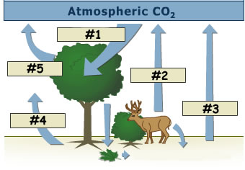
- Deconstruct the carbon cycle as it relates to photosynthesis, cellular respiration, decomposition and climate change. Label #1, 2, and 3 in this diagram using these words: respiration, photosynthesis, decomposition.

- Summarize the nitrogen cycle (including the role of nitrogen fixing bacteria).
  - What do nitrogen fixing bacteria convert in the nitrogen cycle?
  - Relate the importance of the nitrogen cycle to synthesis of proteins and DNA.
    - Which 4 main elements make up proteins?
    - Which 5 main elements make up nucleic acids?
    - Why is the nitrogen cycle important in the synthesis of proteins and DNA?
- Define factors that influence climate such as:
  - greenhouse effect (relate to carbon cycle and human impact on atmospheric CO2)
    - Describe the greenhouse effect. Relate it to sitting in a car on a hot sunny day.
  - natural environmental processes (relate to volcanic eruption and other geological processes)
- Explain the recycling of matter within ecosystems and the tendency toward a more disorganized state.
  - Give 2 examples of matter being recycled.
  - Which 2 groups of organisms are responsible for decomposition?
- Analyze energy pyramids for direction and efficiency of energy transfer.
  - Draw an energy pyramid. Include 4 trophic levels. Label each trophic level. Assume that the producers begin with 100,000 kj of energy. Explain the 10% rule by labeling how much energy every other level would then have.
- Living systems require a continuous input of energy to maintain organization.
  - What is radiant energy?
  - What is chemical energy?
  - How is radiant energy converted to chemical energy?
    - Which organisms are responsible for this conversion?
    - What is the name of the process?
    - What are the end products of the process?
- Explain how energy flows through an ecosystem in relation to producers and consumers.
- Which type of energy do ecosystems required a constant supply of?

Bio.2.1.2 Analyze the survival and reproductive success of organisms in terms of behavioral, structural, and reproductive adaptations.
- Analyze how various organisms accomplish the following life functions through adaptations within particular environments (example: water or land) and that these adaptations have evolved to ensure survival and reproductive success:
  - Transport and Excretion – how different organisms get what they need to cells; how they move waste from cells to organs of excretion.
    - How do humans transport nutrients and waste?
    - How do plants transport nutrients and waste?
    - How do humans excrete waste?
    - How do plants excrete waste?
  - Focus is on maintaining balance in pH, salt, and water.
    - How do organisms maintain balances in pH?
    - How do organisms maintain balances in salt?
    - How do organisms maintain balances in water?
  - Include plants - vascular and nonvascular. (complete the table):
 | Xylem present | Phloem Present | Vascular Tissue present | No vascular tissue present
Vascular Plant
Nonvascular Plant
  - Respiration – how different organisms take in and release gases (carbon dioxide or oxygen, water vapor); cellular respiration
    - Which organs does a human use for respiration?
    - Which parts do plants use for respiration?
    - How is the releasing of gases related to cellular respiration?
  - Nutrition – feeding adaptations and how organisms get nutrition (autotrophic and heterotrophic) and how they break down and absorb foods.
    - List 3 autotrophs.
    - List 3 heterotrophs
  - Reproduction, Growth and Development
    - Check which of these terms are related to sexual and asexual reproduction:
 | Mitosis | Meiosis | Seeds | Spores | Placental mammals
Sexual
Asexual

    - State how Sexual reproduction is different from asexual.
    - What are eggs?
    - What does a seed contain?
    - What are spores?
      - List 2 organisms that release spores.
    - What is a placenta?
      - Give 3 examples of placental mammals.

- Analyze behavioral adaptations that help accomplish basic life functions such as suckling, taxes/taxis, migration, estivation, and hibernation, habituation, imprinting, classical conditioning (e.g. Pavlov’s dog–stimulus association), and trial and error learning.
  - Check which of these are innate behaviors and which are learned behaviors:

 | Suckling | Taxes/taxis | Migration | Estivation | Hibernation
Innate
Learned

 | Classical conditioning | Trial and error learning | Habituation | imprinting
Innate
Learned

- Match these with their definitions/examples:
  - Suckling 1. Instinctive seasonal movement of animals.
  - Taxes/taxis 2. An instinct of mammals that helps with feeding.
  - Migration 3. Insects moving toward light.
  - Estivation 4. Reduced metabolism during cold months.
  - Hibernation 5. An animal forms a social attachment to another object.
  - Habituation 6. Birds learn that grass/twigs make better nests than empty cans.
  - Imprinting 7. Learning by association.
  - Classical conditioning 8. Reduced metabolism during intense heat.
  - Trial and error learning 7. A learned behavior that occurs when an animal is repeatedly
given a stimulus not associated with any punishment or reward.

Bio 2.1.3 Explain various ways organisms interact with each other (including predation, competition, parasitism, mutualism) and with their environments resulting in stability within ecosystems.
- Identify and describe symbiotic relationships (give examples):
 | One organism benefits, the other is harmed | Both organisms benefit | Trichonympha live in the guts of parasites and digest cellulose | Tapeworms | Lichens (algae and fungus) | Bedbugs
Mutalism
Parasitism

- Exemplify various forms of communication and territorial defense including:
  - communication within social structure using pheromones (Examples: bees, ants, termites)
    - define pheromones and give an example of how these organisms use them.
  - courtship dances
    - Give an example of an organism that uses courtship dances.
  - territorial defense (Example: fighting fish).
    - Give 2 other examples of territorial defense.
- Explain patterns in predator/prey and competition relationships and how these patterns help maintain stability within an ecosystem with a focus on population dynamics.

Bio.2.1.4 Explain why ecosystems can be relatively stable over hundreds or thousands of years, even though populations may fluctuate (emphasizing availability of food, availability of shelter, number of predators and disease).
- Generalizing that although some populations have the capacity for exponential growth, there are limited resources that create specific carrying capacities and population sizes are in a dynamic equilibrium with these factors. (e.g. food availability, climate, water, territory).
- Interpret various types of population graphs:
  - human population growth graphs indicating historical and potential changes
  - factors influencing birth rates and death rates
  - effects of population size
  - population density
  - resource use on the environment.
- Explain how disease can disrupt ecosystem balance. Match these examples with their definitions:
  - AIDS 1. an introduced species caused by a fungus & spread by elm bark beetle.
  - Influenza 2. associated with harmful algal blooms and fish kills in NC.
  - Tuberculosis (TB) 3. seasonal infectious disease caused by an RNA virus.
  - Dutch Elm Disease 4. final stage of HIV disease which causes severe immune deficiency
  - Pfiesteria 5. contagious bacterial infection that involves the lungs

- How are these diseases spread? Match them with their method:
 | AIDS | Influenza | Tuberculosis | Dutch Elm Disease | Pfiesteria
Air
Blood/Body fluids
Insects
Direct contact with the toxins released by this organism

- Does your risk of contracting AIDS, The Flu, and TB increase if you:
- Are in frequent contact with people who have these diseases?
- Have poor nutrition?
- Live in crowded or unsanitary living conditions?

Biology Essential Standard Bio.2.2
Understand the impact of human activities on the environment (one generation affects the next).

Bio.2.2.1 Infer how human activities (including population growth, pollution, global warming, burning of fossil fuels, habitat destruction and introduction of nonnative species) may impact the environment.

- Summarize how humans modify ecosystems through population growth, technology, consumption of resources and production of waste.
- Interpret data regarding the historical and predicted impact on ecosystems and global climate.

- Explain factors that impact North Carolina ecosystems.
  - How does acid rain affect the mountains of North Carolina?
  - Is erosion a problem on NC beaches? If so, how are we taking care of the problem?
  - How is urban development in the Piedmont leading to habitat destruction/water runoff and what are some of the consequences?
  - How are waste lagoons on hog farms affecting the environment?
  - How do you know that Kudzu is an invasive plant?

Bio.2.2.2 Explain how the use, protection and conservation of natural resources by humans impact the environment from one generation to the next.

- Explain the impact of humans on natural resources (be sure to give examples):
  - resource depletion
  - deforestation
  - pesticide use
  - bioaccumulation
- List 5 ways you can exemplify conservation methods and stewardship:

Biology Essential Standard 3.1
Explain how traits are determined by the structure and function of DNA.

Bio.3.1.1 Explain the double-stranded, complementary nature of DNA as related to its function in the cell.

• Develop a cause-and-effect model relating the structure of DNA to the functions of replication and protein synthesis:

Use these words to complete #57: genes, double helix, protein, cytosine, S phase, nitrogenous, thymine, phosphate-sugar, protein, hydrogen (Note that protein is used twice!)

- The structure of DNA is a _________________________ or “twisted ladder” structure. The sides are composed of alternating __________________________ groups and “rungs of the DNA ladder” are composed of complementary ________________ base pairs.
  - Adenine (A) bonds with _________________________
  - Guanine (G) bonds with _________________________
  - Which type of weak bonds holds nitrogen bases together?
  - The sequence of nucleotides in DNA codes for ___________________, which is central key to cell function and life.
  - Replication occurs during the ________________of the cell cycle and allows daughter cells to have an exact copy of parental _______________.
  - Cells respond to their environments by producing different types and amounts of ______________.
  - With few exceptions, all cells of an organism have the same DNA but differ based on the expression of ________________.
- How is injury repair related to the overproduction or underproduction of proteins?
- How is cancer related to the overproduction or underproduction of proteins?

Bio.3.1.2 Explain how DNA and RNA code for proteins and determine traits.

Use these words to answer #60: functional, peptide, transcription, ribosome, protein, structural, tRNA
- Explain the process of protein synthesis:
  - _______________________ produces an RNA copy of DNA, which is further modified into the three types of RNA
  - mRNA traveling to the __________________ (rRNA)
  - Translation – _____________ supplies appropriate amino acids
  - Amino acids are linked by ______________ bonds to form polypeptides.
  - Polypeptide chains form __________________ molecules.
  - Proteins can be ___________________ (forming a part of the cell materials) or ____________________ (hormones, enzymes, or chemicals involved in cell chemistry).
- Interpret a codon chart to determine the amino acid sequence produced by a particular sequence of bases.
  - Determine the sequence of amino acids that will result from this sequence of DNA:
    - AAT TTC CGA ATG GGA
  - Explain how an amino acid sequence forms a protein that leads to a particular function and phenotype (trait) in an organism.

Bio.3.1.3 Explain how mutations in DNA that result from interactions with the environment (i.e. radiation and chemicals) or new combinations in existing genes lead to changes in function and phenotype.

- Understand that mutations are changes in DNA coding and can be deletions, additions, or substitutions.
  - Define deletion.
  - Define addition.
  - Define substitution.
- Mutations can be random and spontaneous.
  - List 3 mutagens that can also cause mutations:
- Develop a cause and effect model in order to describe how mutations:
  - How does changing an amino acid sequence change a protein and it’s function?
  - What does this do to the phenotype of the organism?
- Only mutations in these can result in heritable changes: (circle the correct ones):
  - Sperm stomach liver egg skin nerve blood

Biology Essential Standard 3.2
Understand how the environment, and/or the interaction of alleles, influences the expression of genetic
traits.

Bio.3.2.1 Explain the role of meiosis in sexual reproduction and genetic variation.

- List 3 ways meiosis is different from mitosis.
- What occurs during prophase I of meiosis and why is it important?
- Infer the importance of the genes being on separate chromosomes as it relates to meiosis.
- Explain how the process of meiosis leads to independent assortment and ultimately to greater genetic diversity.

- Exemplify sources of genetic variation in sexually reproducing organisms including: (give examples if you are able):
  - crossing over
  - random assortment of chromosomes
  - gene mutation
  - nondisjunction
  - fertilization

- Compare meiosis and mitosis including type of reproduction (asexual or sexual), replication and separation of DNA and cellular material, changes in chromosome number, number of cell divisions, and number of cells produced in a complete cycle. Complete the table:
 | Sexual or asexual reproduction | Is DNA replicated? | Changes in chromosome from parent to daughter cells? | Number of cell divisions: | Number of daughter cells produced:
Mitosis
Meiosis

Bio.3.2.2 Predict offspring ratios based on a variety of inheritance patterns (including dominance, co-dominance, incomplete dominance, multiple alleles, and sex-linked traits).

- Interpret Punnett squares (monohybrid only) to determine genotypic and phenotypic ratios.
  - In rabbits, black fur is dominant over white fur. Show the cross of a heterozygous black male with a homozygous white female.
  - Blue eyes are dominant to red eyes in rabbits. Show a heterozygous blue-eyed rabbit crossed with a red-eyed rabbit.
- Understand that dominant alleles mask recessive alleles.
  - Determine parental genotypes based on offspring ratios:
    - In humans, brown eyes (B) are dominant over blue (b). A brown-eyed man marries a blue-eyed woman and they have three children, two of whom are brown-eyed and one of whom is blue-eyed. Draw the Punnett square that illustrates this marriage. What is the man’s genotype? What are the genotypes of the children?
  - Interpret karyotypes (gender, and chromosomal abnormalities). What is the gender of this child? Which genetic disorder does this child have?

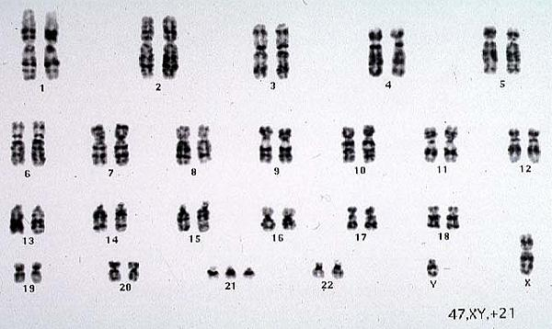

  - Recognize a variety of intermediate patterns of inheritance (codominance and incomplete dominance).
    - Think pINC – incomplete dominance (red x white snapdragons = pink snapdragons)
    - Think COw – codominance (red cow x white cow = roan cow)
  - Recognize that some traits are controlled by more than one pair of genes and that this pattern of inheritance is identified by the presence of a wide range of phenotypes (skin, hair, and eye color).
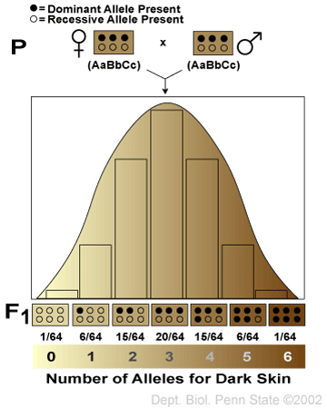
  - Interpret autosomal inheritance patterns: sickle cell anemia including the relationship to malaria (incomplete dominance), cystic fibrosis (recessive heredity), and Huntington’s disease (dominant heredity).
    - Explain sickle cell anemia’s relationship to malaria due to incomplete dominance.
    - Explain how two normal parents could have a child with cystic fibrosis.
    - What are some of the symptoms of Huntington’s disease?
  - Solve and interpret codominant crosses involving multiple alleles including blood typing problems. (Blood Types: A, B, AB and O and Alleles: IA, IB, and i). Students should be able to determine if parentage is possible based on blood types.
    - Pretend that Brad Pitt is homozygous for the type B allele, and Angelina Jolie is type “O.” What are all the possible blood types of their baby?
      - Two parents think their baby was switched at the hospital. It’s 1968, so DNA fingerprinting technology does not exist yet. The mother has blood type “O,” the father has blood type “AB,” and the baby has blood type “B.” Complete a Punnett square showing all possible genotypes for children produced by this couple
        - Mother’s genotype: _______
        - Father’s genotype: _______
        - Baby’s genotype: ______ or ________
        - Punnett square showing all possible genotypes for children produced by this couple
        - Was the baby switched?
  - Understand human sex chromosomes and interpret crosses involving sex-linked traits (color-blindness and hemophilia).
    - Why are males more likely to express a sex-linked trait?
    - Colorblindness is inherited as a sex-linked recessive disease. An affected male marries a heterozygous female. Draw a Punnett square of the possible offspring. What is the chance that they will have an affected child? Could any of their daughters be affected?
  - Interpret phenotype pedigrees to identify the genotypes of individuals and the type of inheritance:
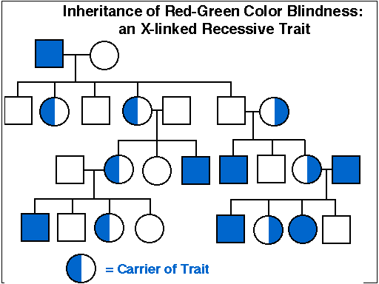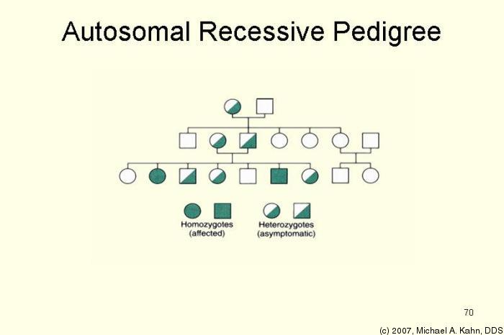

Bio.3.2.3 Explain how the environment can influence the expression of genetic traits.

- Develop a cause-and-effect relationship between environmental factors and expression of a particular genetic trait. Examples include the following: (Match each with the environmental cause.)
  - lung/mouth cancer 1. diet/exercise and genetic interaction
  - skin cancer 2. diet/exercise and genetic interaction
  - diabetes 3. tobacco use
  - PKU 4. diet
  - heart disease 5. vitamin D, folic acid and sun exposure

Biology Essential Standard 3.3
Understand the application of DNA technology.

Bio.3.3.1 Interpret how DNA is used for comparison and identification of organisms.
- Summarize the process of gel electrophoresis as a technique to separate molecules based on size. Students should learn the general steps of gel electrophoresis
  - What are used cut DNA into different sized fragments?
  - Which fragments move more slowly, the long ones or the short ones?
- Interpret or “read” a gel: Which suspect should be questioned about the crime?
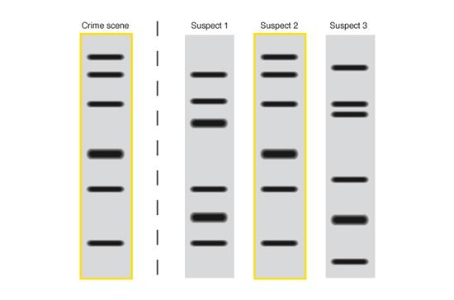

- Exemplify applications of DNA fingerprinting:
  - How can DNA fingerprinting identify individuals?
  - How can DNA fingerprinting be used to identify and catalog endangered species.

Bio.3.3.2 Summarize how transgenic organisms are engineered to benefit society.
- Generalize the applications of transgenic organisms (plants, animals, & bacteria) in agriculture and industry including pharmaceutical applications such as the production of human insulin. Which of these can be produced by transgenic organisms?

 | Human insulin | Antibodies | Hormones | Vaccines | Enzymes
Produced by transgenic organisms?

- Summarize the steps in bacterial transformation (insertion of a gene into a bacterial plasmid, getting bacteria to take in the plasmid, selecting the transformed bacteria, and producing the product).
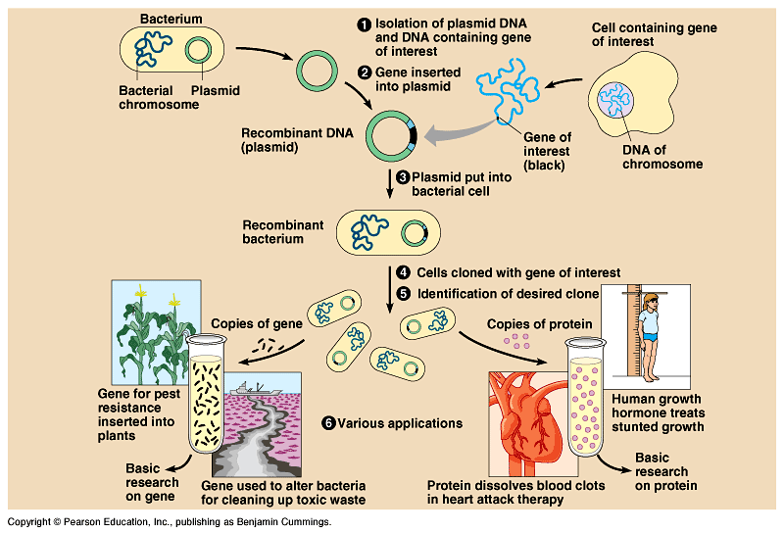

Bio.3.3.3 Evaluate some of the ethical issues surrounding the use of DNA technology (including cloning, genetically modified organisms, stem cell research, and Human Genome Project).
- Identify the reasons for establishing the Human Genome Project.
  - Recognize that the project is useful in determining whether individuals may carry genes for genetic conditions and in developing gene therapy.
  - Evaluate some of the science of gene therapy. (e.g. Severe Combined Immunodeficiency and Cystic Fibrosis)
- Critique the ethical issues and implications of genomics and biotechnology:
  - stem cell research
  - gene therapy
  - genetically modified organisms

Biology Essential Standard 3.4
Explain the theory of evolution by natural selection as a mechanism for how species change over time.

Bio.3.4.1 Explain how fossil, biochemical, and anatomical evidence support the theory of evolution.
- Summarize the hypothesized early atmosphere and experiments that suggest how the first “cells” may have evolved and how early conditions affected the type of organism that developed
(use these words: multicellular, eukaryotic, prokaryotic, anaerobic, photosynthetic)
  - First organisms were believed to be: ____________________ and ____________________.
  - They were then ________________________.
  - Then ________________________________.
  - And then _______________________________.
- Summarize how fossil evidence informs our understanding of the evolution of species and what can be inferred from this evidence.
  - Where are the more primitive organisms found – in the lower strata or upper strata?
  - Where are the more derived traits located – in the lower strata or upper strata?
  - Please analyze the diagram and answer the questions for #18 below:
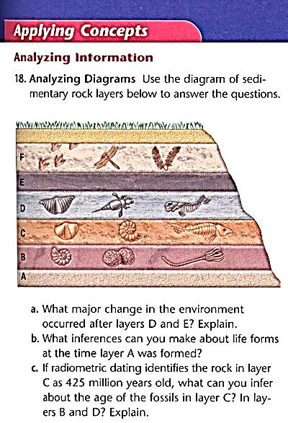
- Generalize what biochemical (molecular) similarities tell us about evolution. Which of these organisms are most closely related?
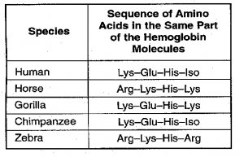
- Generalize what shared anatomical structures (homologies) tell us about evolution.
Bio.3.4.2 Explain how natural selection influences the changes in species over time.
- Who developed the concept of natural selection?
- Develop a cause and effect model for the process of natural selection. Explain what each of these statements mean:
  - Species have the potential to increase in numbers exponentially.
  - Populations are genetically variable due to mutations and genetic recombination.
  - There is a finite supply of resources required for life.
  - Changing environments select for specific genetic phenotypes.
  - Those organisms with favorable adaptations survive, reproduce and pass on their alleles.
  - The accumulation and change in favored alleles leads to changes in species over time.
  - Illustrate the role of geographic isolation in speciation.

Bio.3.4.3 Explain how various disease agents (bacteria, viruses, chemicals) can influence natural selection.
- Develop a cause and effect model for the role of disease agents in natural selection including evolutionary selection of resistance to antibiotics and pesticides in various species, passive/active immunity, antivirals and vaccines.
  - Explain why some bacteria are resistant to antibiotics.
  - Explain why some insects are resistant to pesticides.
  - Complete this table by checking the related terms (some may have more than 1 checkmark!)
 | Passive immunity | Active Immunity | Antivirals | Vaccines | Antibiotics
Life lasting immunity
Short term immunity
Destroy the cell walls of bacteria
Slow growth of viruses
Dead/weakened pathogens
Contracting chicken pox or the measles
A mother breast-feeding her child

Biology Essential Standard 3.5
Analyze how classification systems are developed upon speciation.

Bio.3.5.1 Explain the historical development and changing nature of classification systems.
- Generalize the changing nature of classification based on new knowledge generated by research on evolutionary relationships and the history of classification system.
  - How many kingdoms of organisms did the first classification system (Aristotle and Linnaeus) have and what where the categories?
  - How many kingdoms did the next classification system have and what where the categories?
  - How many kingdoms are in the current classification system? Which kingdom was split from the previous system?
  - Which category is now above a kingdom and how many are there?
Bio.3.5.2 Analyze the classification of organisms according to their evolutionary relationships (including dichotomous keys and phylogenetic trees).
- Classify organisms using a dichotomous key. Classify these leaves.
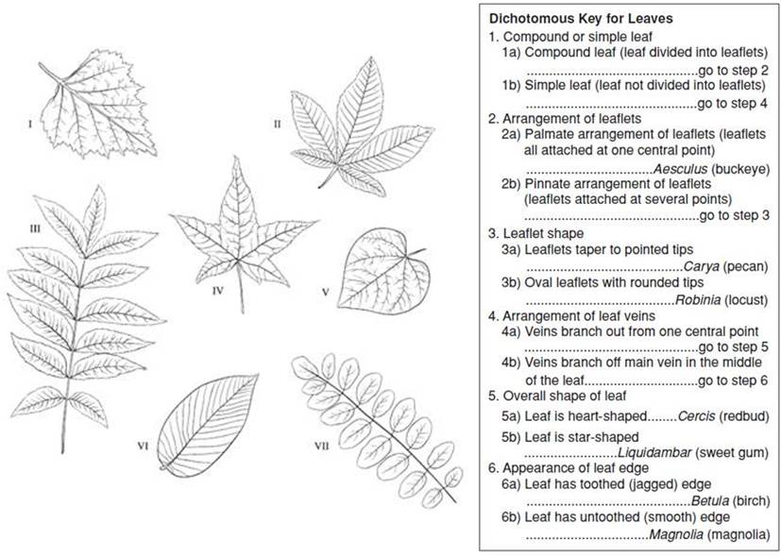

- Compare organisms on a phylogenetic tree in terms of relatedness and time of appearance in geologic history.

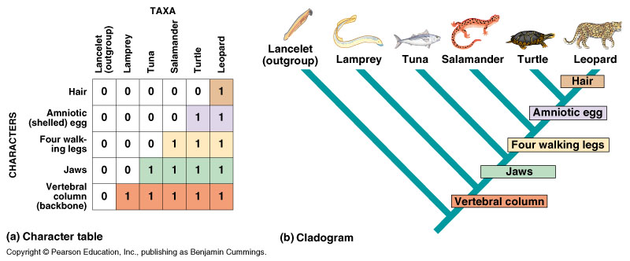

Biology Essential Standard 4.1
Understand how biological molecules are essential to the survival of living organisms.

Bio.4.1.1 Compare the structures and functions of the major biological molecules (carbohydrates, proteins, lipids, and nucleic acids) as related to the survival of living organisms.
- Compare the structure and function of each of the listed organic molecules in organisms. Check which are examples or are related to these biological molecules:
 | Insulin | Glucose | Cellulose | DNA | Hemoglobin | Steroids | Starch | Enzymes | hemoglobin
Carbohydrate
Lipid
Protein
Nucleic Acid

 | Glycogen | RNA | phospholipids | Hexagon shape | Amino Acids | Protein synthesis | Denature | Cell membranes | Quick Energy
Carbohydrate
Lipid
Protein
Nucleic Acid

  - Carbohydrates
    - What is the function of glucose?
    - What is the function of cellulose and where is it found?
    - Where is starch stored in plants?
    - What is glycogen and how is it related to starch?
  - Proteins
    - What is the function of insulin and where is it produced?
    - What is the function of enzymes?
    - What is the function of hemoglobin and where is it found
  - Lipids
    - What is the function of phospholipids/where are they found?
    - Why are steroids important to our bodies?
  - Nucleic Acids
    - What is the function/purpose of DNA?
    - What is the function/purpose of RNA?

Bio.4.1.2 Summarize the relationship among DNA, proteins and amino acids in carrying out the work of cells and how this is similar in all organisms.
- Recall that the sequence of nucleotides in DNA codes for specific amino acids which link to form proteins.
  - List them amino acid sequence that would result from this DNA base sequence:
A-A-G - G-A-T - C-C-G

mRNA Codon | Amino Acid
A-G-A | ARG
C-U-A | LEU
G-G-C | GLY
U-U-C | PHE

  - What part of an amino acid makes it different from other amino acids if they all have similar structures and elements?

  - List the five nitrogenous bases found in nucleic acids. (You can use the letters.)
  - Are these five bases the same for all organisms?

- Summarize the process of protein synthesis. Label this diagram:
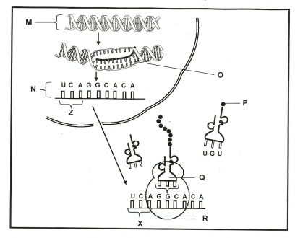

Bio.4.1.3 Explain how enzymes act as catalysts for biological reactions.
- Develop a cause and effect model for specificity of enzymes.
  - Explain how/why enzymes are specific by using the example of eating a cracker vs. a piece of meat.
    - Why will the enzymes that break down a cracker not break down meat?

Please use this word bank to answer the next questions:
all, lower, pH, re-usable, 3-D, speed up, temperature, specific, catalysts

  - The folding of proteins produces a _____________ shape that is linked to function.
  - Enzymes are proteins that ________________ chemical reactions. Because of this, enzymes are called __________________.
  - Enzymes _______________ the activation energy of a reaction.
  - Enzymes are _______________ and ________________.
  - Enzymes are affected by factors such as __________ and _____________________.
  - Describe the lab that we performed that showed how these factors affect enzymes.
  - Enzymes are necessary for _________ biochemical reactions!

Biology Essential Standard 4.2
Analyze the relationships between biochemical processes and energy use in the cell.

Bio.4.2.1 Analyze photosynthesis and cellular respiration in terms of how energy is stored, released, and transferred within and between these systems.

- Analyze overall reactions including reactants and products for photosynthesis and cellular respiration and factors which affect their rates.
  - Write the equation for photosynthesis.
  - Write the equation for cellular respiration.
  - How would low levels of carbon dioxide or water affect the rate of photosynthesis?
  - How would high levels of oxygen and glucose affect the rate of cellular respiration?
  - How would temperature affect photosynthesis and cellular respiration?
  - How would pH affect photosynthesis and cellular respiration?
  - How does the amount of light affect photosynthesis?

- Compare these processes with regard to efficiency of ATP formation, the types of organisms
using these processes, and the organelles involved.
  - Which organisms perform photosynthesis?
  - Which organelles are involved?
  - Which organisms perform cellular respiration?
  - Which organelles are involved?
  - How is anaerobic respiration different from aerobic respiration?
  - What is another name for anaerobic respiration?
  - In which organisms does lactic acid fermentation occur?
  - In which organisms does alcoholic fermentation occur?
  - How many ATP are produced in aerobic respiration compared to anaerobic respiration?

Bio 4.2.2 Explain ways that organisms use released energy for maintaining homeostasis (active transport).
- Conclude that energy production by organisms is vital for maintaining homeostasis and that maintenance of homeostasis is necessary for life.
  - Why do cells use active transport?
  - What do cells need in order to perform active transport?
  - List 1 thing cells rid of during active transport and give an example of this in your body.
  - List 3 reasons why organisms use the process of locomotion.
  - List 3 molecules that your body is synthesizing right now.

