Chemistry NCFE Guided Review Standard 3.2
(Solutions, Acids/Bases)

Chm.3.2.1 Classify substances using the hydronium and hydroxide concentrations.
Chm.3.2.2 Summarize the properties of acids and bases.

 | Acid | Base
Formula
Taste/Feel
Litmus test
pH
Conductivity
Reaction with Metals

Concentration:
Strength:
Calculating pH, pOH, [H⁺], and [OH⁻]
pH Scale:

*Use the reference table (pick the equation that will solve for what you want using what you have)
Examples:
- What is the pH of a solution with a pOH of 12.5?

- What is the pOH of a H₂SO₄ solution with a concentration of 4.5M?
Be able to interpret pH indicator color changes on a table such as:
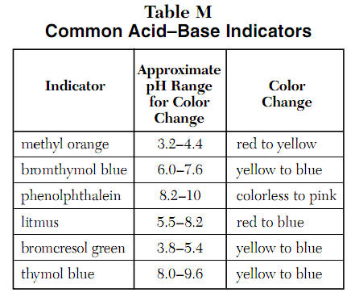
Example: Based on the results of testing colorless solutions with indicators, which solution is most acidic?
- a solution in which bromthymol blue is blue
- a solution in which bromsresol green is blue
- a solution in which phenolphthalein is pink
- a solution in which methyl orange is red

Chm.3.2.3 Infer the quantitative nature of a solution (molarity, dilution, and titration with a 1:1 molar ratio).
Molarity Equation

Examples:
- What is the molarity of solution made with 4.5 moles of sodium chloride and 9 liters of water?

- What concentration of solution can be made by adding 68 g of magnesium chloride to 500 ml of water?

- How many grams of lithium oxide are needed to create 8000 mL of a 3.2 M solution?

Dilutions and Titrations
Dilution Equation: Titration Equation:

Examples:
- 100.0 mL of 2.500 M KBr solution is on hand. You need 0.5500 M. What is the final volume of solution which results?

- A 25 ml solution of 0.5 M NaOH is titrated until neutralized into a 50 ml sample of HCl. What was the concentration of the HCl?

Titration Curves
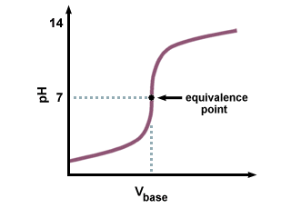
Chm.3.2.4 Summarize the properties of solutions.
Definition of Solution:

Types of Solutions
Type | Made From | Example
Solid
Liquid
Gaseous
Aqueous

Electrolytic vs. Nonelectrolytic
Electrolytic:
Example:
Nonelectrolytic:
Example:
Colligative Properties
Depend on _________ of __________, not _________ of particles.
- Vapor Pressure Lowering
What is it?
Why does it happen?
- Boiling Point Elevation
What is it?
Why does it happen?

- Freezing Point Depression
What is it?

Why does it happen?
Chm.3.2.5 Interpret solubility diagrams.

1. How many grams of potassium nitrate can dissolve in 200 grams of water at 40 degrees Celsius?

2. If 100 grams of sodium nitrate are dissolved in 100 grams of water at 50 degrees Celsius, what type of solution will result?
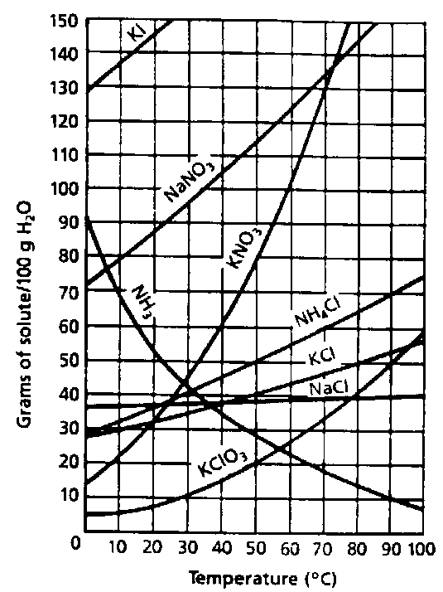
Chm.3.2.6 Explain the solution process.
Parts of Solution
Solute:
Solvent:
“Like dissolves like”
Solubility
Saturated:
What happens past the saturation point?

Unsaturated:

Supersaturated:
How is this achieved?

How does temperature affect solubility?

How does pressure affect solubility (for gasses)?

Sample Questions
1. Based on hydroxide ion concentration, which unknown substance would be an acid?
- Substance A, [OH-] = 1.0 x 10-2M
- Substance B, [OH-] = 1.0 x 10-4M
- Substance C, [OH-] = 1.0 x 10-6M
- Substance D, [OH-] = 1.0 x 10-8M
2. What volume of 0.200M HCl will neutralize 10.0mL of 0.400M KOH?
- 40.0mL
- 20.0mL
- 8.00mL
- 5.00mL
3. Heat is added to a solution to
- increase the solubility of a solid solute.
- increase the solubility of a gas solute.
- increase the miscibility of the solution
- increase the degree of saturation of the solution.
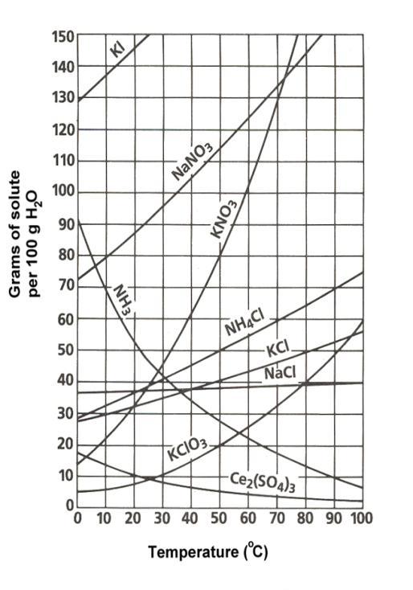
4. How many grams of KCl are required to make a saturated solution in 50.0 g of water at 80oC?
- 25.0 g
- 50.0 g
- 100.0 g
- 150.0 g
5. Given the data table below, which substance is an acid?
 | Substance
 | W | X | Y | Z
Tastes Bitter | ? | Yes | Yes | No
Tastes Sour | No | No | ? | Yes
Feels Slippery | No | Yes | Yes | ?
Turns Litmus Blue | Yes | Yes | Yes | ?
Turns Litmus Red | ? | No | No | Yes

- Substance W
- Substance X
- Substance Y
- Substance Z

