Chemistry NCFE Guided Review/Questions 3.1
(Reaction Rates and Equilibrium)

Chm.3.1.1 Explain the factors that affect the rate of a reaction (temperature, concentration, particle size and presence of a catalyst).
Reaction Rates

The speed of the reaction OR The change in concentration of reactants over time.

Factors affecting rate;
- Type of reactants
- Surface area =
- Temperature =
- Concentration of reactants =
- Catalysts: a substance that lowers the activation energy of a chemical reaction.

Enthalpy

∆E = ∆H = ENTHALPY = heat of the reaction = E_{products} - E_{reactants}

Exothermic ∆H = is negative
Endothermic ∆H = is positive

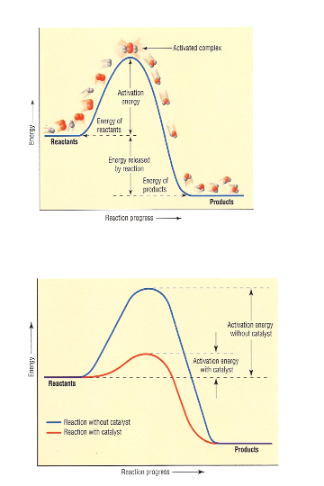
1. Are the forward reactions endothermic or exothermic?

2. Which has more energy, reactants or products?

3. What does the catalyst do?

4. Is the catalyst part of the rxn?

5. Is ∆H for this forward rxn positive or negative?
How do you know?

Facts about Reactions
Indications that a reaction has taken place are

1.
2.
3.
4.
Chm.3.1.2 Explain the conditions of a system at equilibrium.
-When writing equilibrium constant expressions, remember that ______________ become ___________ and ___________ remain the same.
Example: Write equilibrium expressions for the forward and reverse reactions of:
A_{(aq)} + 2B_{(aq)} AB_{2(aq)}
K_{eq (f)} =

K_{eq} _{(r)} =
-Only include reactants/products that are in the _____________ or ____________ phases (not _________ and ________)
Example: Write the equilibrium expression for the forward reaction of:
2 NaHCO_{3 (aq)} Na₂CO_{3 (s) +} CO_{2 (g)} + H₂O_{(l)}
K_{eq} =
- If K_{eq} > 1 then ______________________________________
- If K_{eq} < 1 then ______________________________________
Chm.3.1.3 Infer the shift in equilibrium when a stress is applied to a chemical system (Le Chatelier’s Principle).
Changes to a System at Equilibrium
3 ways to apply a stress to a system
a. Change the _______________
b. Change the _______________
c. Change the _______________

Le Chatelier’s Principle states that when a system at equilibrium is subjected to a stress, the system will shift its equilibrium point in order to relieve the stress.

12.6 kcal + H₂ _{(g)} + I_{2 (g)} ↔ 2HI _{(g)}

Which way will the system shift when:
1. Hydrogen is added?
2. Iodine is added?
3. Hydroiodic acid is added?
4. Iodine is removed?
5. Temperature is increased?
6. The pressure is increased?
7. When would pressure affect a system at equilibrium?
8. Write the equilibrium expression for this reaction.
9. What is K if [H₂] = 0.2 , [I₂] = 0.4 , and [HI] = 0.6

Sample Questions
1. When a set amount of marble chips (CaCO3) is added to a small amount of dilute hydrochloric acid, a reaction occurs. What should be done to decrease the rate of reaction the next time the experiment is performed?
  - Use more acid.
  - Stir.
  - Use larger marble chips.
  - Add heat.
2. A scientist observes a chemical reaction as it takes place. How can the scientist so in order to tell if the reaction has achieved equilibrium?
- Measure concentrations of products and reactants over time.
- Monitor the temperature of the reaction over time.
- Measure the pH of the solution over time.
- Wait for the formation of a precipitate.
3. For the reaction 2SO2(g) + O2(g) ⇄ 2SO3(g) + heat
Which action will increase the concentration of SO3?
- removing SO2
- increasing the temperature
- increasing the pressure
- adding a catalyst

