Chemistry NCFE Guided Review 2.1
(Heat and Gas)

2.1.1 Explain the energetic nature of phase changes.
- Physical equilibrium (liquid water-water vapor): vapor pressure depends on ___________ and __________ of particles in solution.
  - Lower temp/concentration = ____________ VP
- When kinetic energy is added to a substance, the particles ________ ______ and begin to __________ (opposite happens when they are cooled).
- Phases of matter are determined by __________ and ___________
- Heat =
  - Unit:
- Temperature =
  - Unit:
  - Unit:
2.1.2 Explain heating and cooling curves (heat of fusion, heat of vaporization, specific heat, melting point, and boiling point).
- Specific Heat Capacity:
  - Symbol:
  - Unit:
  - Usually given on reference table
- Heat of Fusion:
  - Symbol:
  - Unit:
  - Given on reference table (for water)
- Heat of Vaporization:
  - Symbol:
  - Unit:
  - Given on reference table (for water)
Equations
- q = mCΔT
  - Pay attention to units! They matter!
  - If q is negative, heat was _________ (______________)
  - If q is positive, heat was __________ (____________)
- q = mH_{f}
  - used for __________ and ___________
  - Might have a temp in the word problem, ignore it! It’s extra information.
- q = mH_{v}
  - used for __________ and ___________
2.1.3 Interpret the data presented in phase diagrams.
Thermochemistry/Phase Graphics
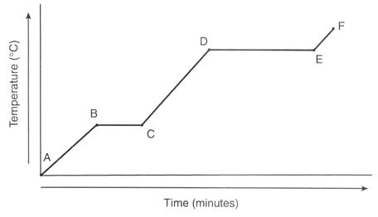
- A-B =
- B-C=
- C-D=
- D-E=
- E-F =
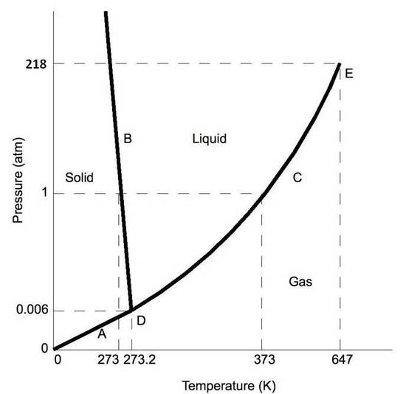
- A =
- B =
- C =
- D =
- E =
2.1.4 Infer simple calorimetric calculations based on the concepts of heat lost equals heat gained and specific heat.
- For a closed system, energy is neither lost nor gained, but __________ from one component to another.
- So, q_{lost =} -q_{gained}
- For example, if one component loses 100 J of heat (-q), the other component gained 100 J of heat (+q).
- Objects with ________ specific heat require _______ energy to change temperature.
2.1.5 Explain the relationships among pressure, temperature, volume, and quantity of gas, both qualitative and quantitative.
- Ideal gas characteristics:
  - Adhere to all aspects of kinetic theory
-
-
-
- Be able to manipulate/use the following equations:
  - PV = nRT
    - Make sure the R unit and the P/V unit match!
    - Make sure to use K for temperatures!
  - P₁V₁ / T₁ = P₂V₂ / T₂
    - Make sure T is in Kelvin (K) and that all other units match!
  - n₁/V₁ = n₂/V₂
    - THIS IS NOT ON THE REFERENCE TABLE! MEMORIZE IT!
  - P_{t} = P₁ + P₂ + P₃ ….
Sample Questions

1. What causes the process of perspiration to be cooling for human skin?
- It involves condensation and is exothermic.
- It involves evaporation and is exothermic.
- It involves condensation and is endothermic.
- It involves evaporation and is endothermic.

2. According to the phase diagram below, what is the boiling point of this substance at a pressure of 1.25 atmospheres?
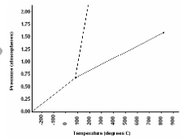
- 100oC
- 150oC
- 300oC
- 500oC
3. 1000 J of heat is added to 2 g of the following substances. Which one will experience the biggest change in temperature?
- aluminum
- copper
- iron
- lead
4. What causes an inflated balloon to shrink when it is cooled?
- because cooling the balloon causes gas to escape from the ball
- because cooling the balloon causes the gas molecules to collide more frequently
- because cooling the balloon causes gas molecules to become smaller
- because cooling the balloon causes the average kinetic energy of the gas molecules to decrease

