Chemistry NCFE Guided Review/Questions 1.1
(Atomic Structure)

Chm.1.1.1 Analyze the structure of atoms, isotopes, and ions.
Subatomic Particles
Particle | Location | Charge | Relative Mass | Determine by:
Proton
Neutron
Electron

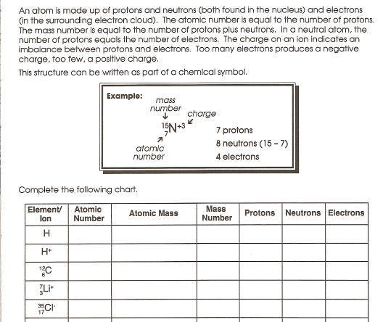

Isotopes

Definition =

Symbols: -or-

Calculating Average Atomic Mass
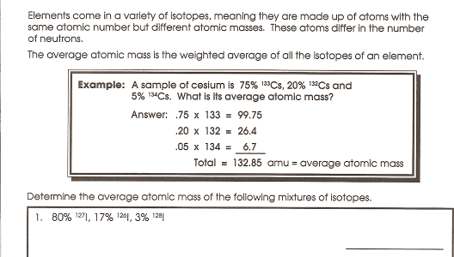

Chm.1.1.2 Analyze an atom in terms of the location of electrons.
Chm.1.1.3 Explain the emission of electromagnetic radiation in spectral form in terms of the Bohr model.
- Ground State =

- Excited State =

When electrons move between energy levels, energy is __________ or ____________ in discrete units called _____________.

Bohr proposed the photon emission model, which explained the characteristic line emission spectrum

When an electron goes from n=4 to n=1 what happens?
What is the wavelength of the electromagnetic radiation emitted?
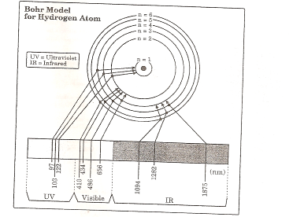

Differences between Bohr Model and Quantum Mechanical Model

 | Bohr | Quantum
Principal Energy Levels Present?
Sublevels Present?
Fixed Electron Orbits?

Chm.1.1.4 Explain the process of radioactive decay using nuclear equations and half-life.
Nuclear Decay

 | symbols | Mass | Charge | Shielding /  penetrating ability
Alpha

Beta

Gamma

Predict the products of the nuclear reactions

a) ²²⁶Ra ²²²Rn +
88 86

₂₃₂ ₂₃₂
b) Th Pa +
⁹⁰ ⁹¹

Concept of half-life

Definition:

Example: An isotope of carbon-18 has a half-life of 6 days. An initial sample with a mass of 200 kg decays for 21 days, how much of the original sample is left?

Fission vs. Fusion

Fission:

Fusion:
Sample Questions

1. Which atomic symbol represents an isotope of sulfur with 17 neutrons?
a.
b.
c.
d.
2. Which is the electronic configuration of calcium?
- 1s22s22p63s23p8
- 1s22s22p63s23p64s2
- 1s22s22p63s23p63d2
- 1s22s22p83s23p6
3. An electron in an atom of hydrogen goes from energy level 6 to energy level 2. What is the wavelength of the electromagnetic radiation emitted?
- 410 nm
- 434 nm
- 486 nm
- 656 nm
4. The half-life of a radioactive isotope is 20 minutes. What is the total amount of 1.00 g of sample of this isotope remaining after 1 hour?
- 0.500 g
- 0.333 g
- 0.250 g
- 0.125 g

